Structural design of a building or bridge

MICRO PROJECT REPORT ON STRUCTURAL DESIGN OF A BRIDGE

1. INTRODUCTION

Structural design is the methodical investigation and calculation of the stability, strength, and rigidity of structures to ensure they safely carry the loads they are expected to withstand throughout their useful life. This micro-project focuses specifically on the structural design principles applied to bridge engineering. A bridge is a structure built to span a physical obstacle (such as a body of water, valley, or road) without closing the way underneath. The primary goal of structural design is to achieve a safe, serviceable, durable, and economical structure.

The design process involves understanding the behavior of materials under various loading conditions, analyzing the distribution of internal forces, and sizing the structural elements (such as beams, decks, piers, and foundations) according to established national and international codes (e.g., IRC, AASHTO, Eurocodes). A failure in structural design can lead to catastrophic collapse, making the rigorous application of engineering mechanics and material science paramount. This report details the fundamental aspects, methodology, and classification systems inherent in modern bridge structural design.
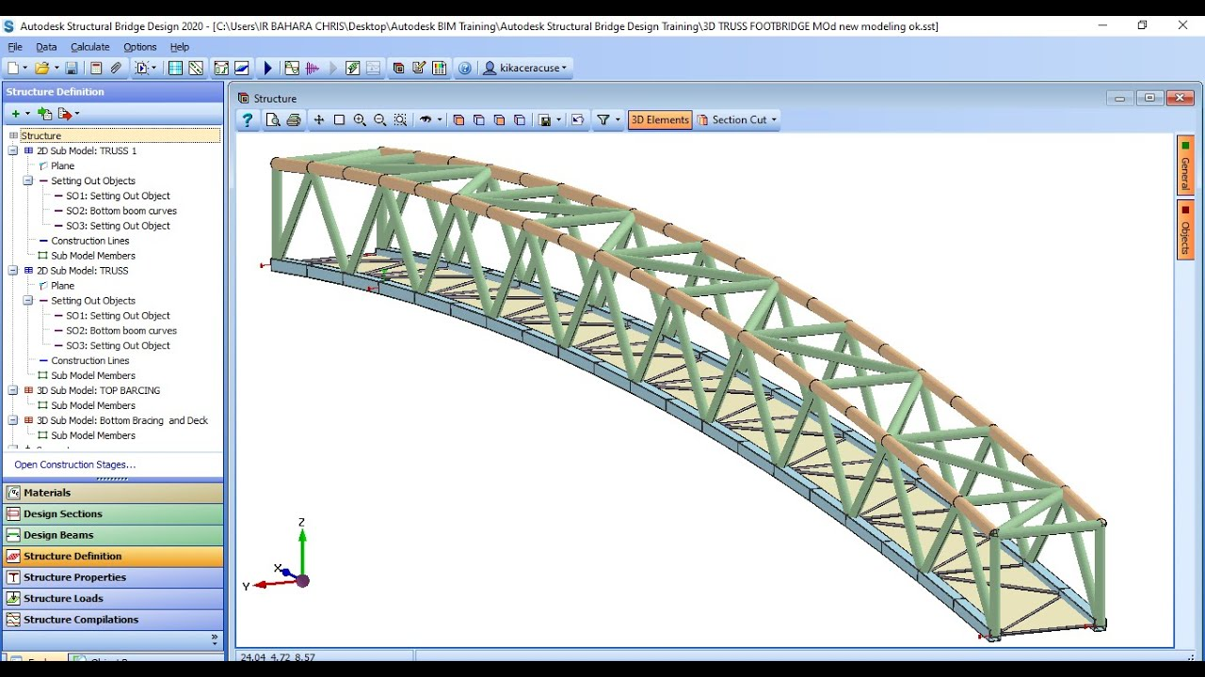

2. HISTORY OF STRUCTURAL DESIGN

The history of structural design is intrinsically linked to human civilization’s need for infrastructure. Early structural design was empirical, relying on trial-and-error and inherited knowledge.

2.1 Ancient Structures

The earliest bridges were simple log or stone beam structures. The Romans revolutionized bridge construction through their mastery of the semicircular arch and the use of opus caementicium (a form of concrete). The arch was a profound structural innovation, allowing forces to be transferred laterally and vertically, spanning much greater distances than simple beams.
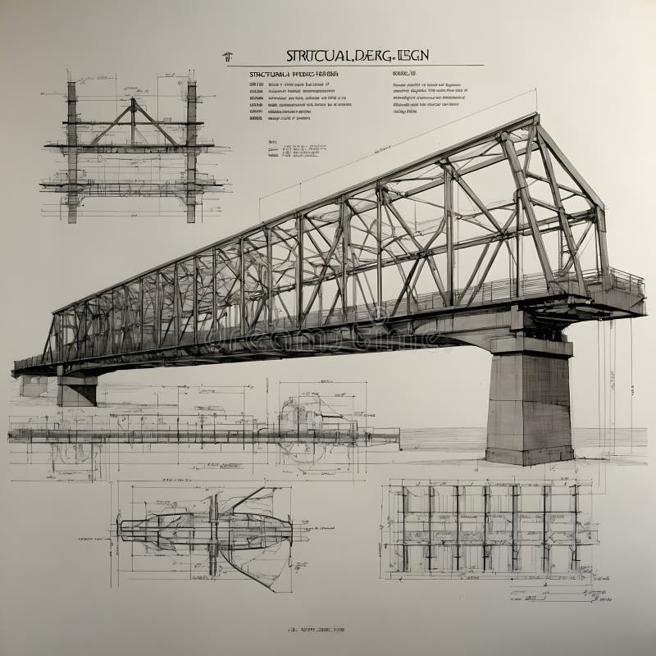

2.2 Medieval and Renaissance Periods

During the medieval era, bridge construction focused heavily on defensive and strategic purposes, often utilizing timber and stone arches. The Renaissance saw the formalization of architectural and engineering principles, though structural analysis remained largely graphical and based on intuition rather than mathematical rigor.

2.3 The Industrial Revolution
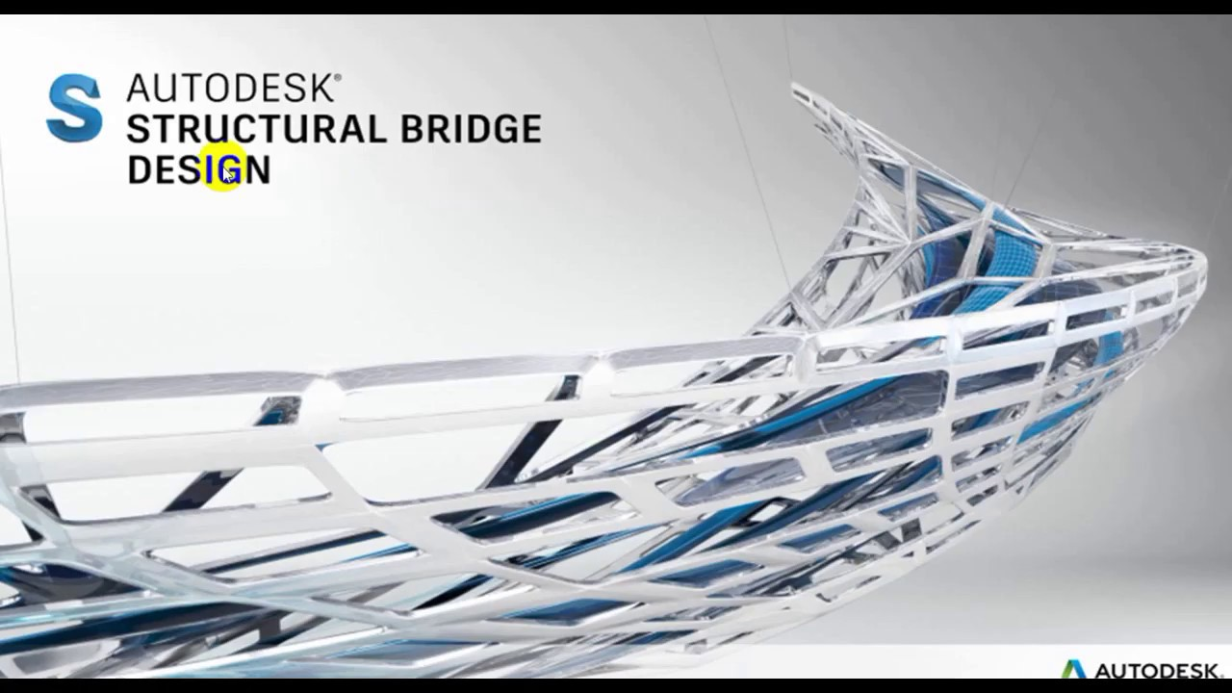
The 18th and 19th centuries marked the true beginning of modern structural engineering. The introduction of wrought iron and later steel allowed for significantly longer spans and lighter structures, leading to the development of truss bridges. Key figures like Euler and Navier developed the mathematical theories of elasticity and beam bending, enabling engineers to predict structural behavior accurately. The development of reinforced concrete in the late 19th century provided a durable, fire-resistant, and versatile material that dominates modern bridge construction.

3. WORKING PRINCIPLE

The fundamental working principle of any bridge structure is the safe and efficient transfer of imposed loads from the point of application (the deck) down to the supporting ground (the foundation). This transfer occurs through a defined load path.
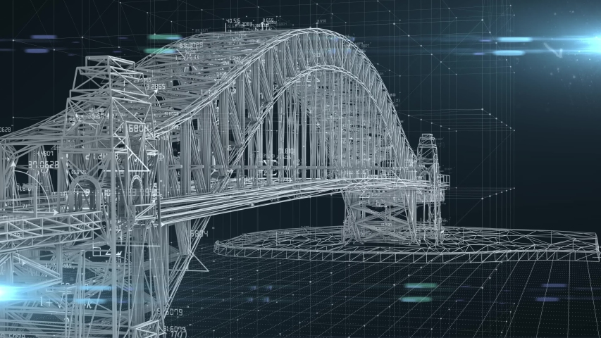

3.1 Load Transfer Mechanism

When a vehicle (Live Load) or the structure's own weight (Dead Load) is applied to the bridge deck, the deck distributes this load to the primary load-carrying elements, typically the girders or trusses. These elements, in turn, transfer the forces (shear, bending moment, and axial forces) horizontally to the abutments or vertically to the piers. Finally, the piers and abutments transmit the total accumulated load to the foundation system (piles or spread footings), which distributes the load safely into the underlying soil or rock strata.

3.2 Principles of Equilibrium

All structural design relies on the principles of static equilibrium. For a structure to be stable, the sum of all external forces and moments acting on it must be zero. The design ensures that the internal stresses (tension, compression, and shear) generated within the material remain below the material's yield strength, incorporating a factor of safety to account for uncertainties in material properties, construction quality, and load estimation.
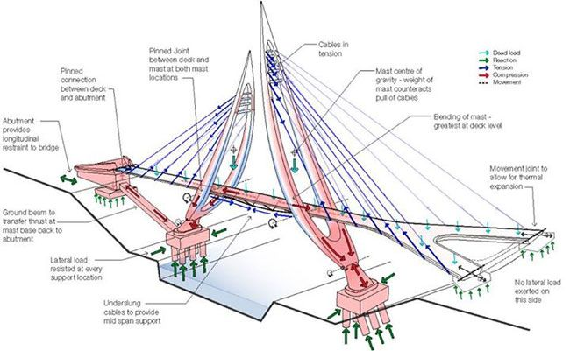

4. METHODOLOGY OF STRUCTURAL DESIGN

The structural design of a bridge follows a systematic, multi-stage methodology to ensure compliance with safety and serviceability requirements.

4.1 Site Investigation and Data Collection
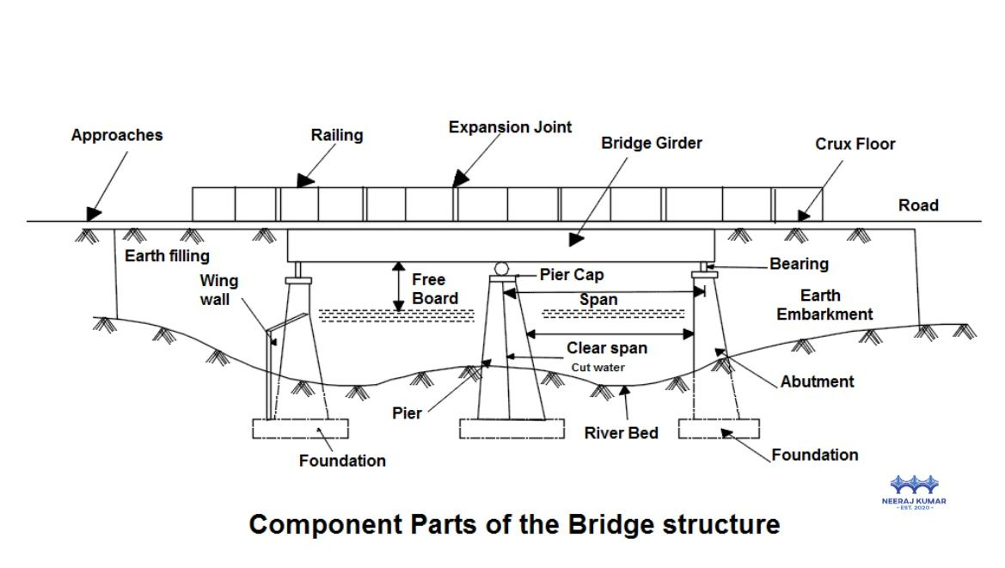
This initial phase involves geotechnical surveys (soil testing), hydrological studies (water flow and scour potential), and topographical mapping. This data informs the selection of the bridge type, span length, and foundation design.

4.2 Conceptual Design and Span Arrangement

Based on site constraints and traffic requirements, preliminary structural schemes are developed. This includes selecting the material (steel, concrete, composite) and the structural form (beam, truss, arch, suspension).

4.3 Load Calculation

All potential loads must be quantified according to relevant codes:
- Dead Loads: Weight of the structure itself (deck, barriers, girders).
- Live Loads: Vehicular traffic (standardized truck loads, e.g., IRC Class A or HS-20).
- Environmental Loads: Wind pressure, seismic forces, temperature effects, and hydrostatic pressure.

4.4 Structural Analysis

Engineers use advanced analytical techniques, often involving Finite Element Method (FEM) software, to model the structure and determine the internal forces (moments, shears, and axial forces) at every critical section under the worst-case load combinations.

4.5 Design of Components

Based on the calculated internal forces, the cross-sectional dimensions, material grades, and reinforcement details (for concrete) or plate thicknesses (for steel) are determined. This phase ensures that the structure has adequate strength (Ultimate Limit State) and satisfactory performance (Serviceability Limit State, controlling deflection and cracking).

4.6 Detailing and Documentation

Detailed drawings, specifications, and construction procedures are prepared, which are essential for the accurate fabrication and erection of the bridge.

5. CLASSIFICATION OF BRIDGES

Bridges can be classified based on various criteria, including the material used and the span length.

5.1 Classification by Material

1. Concrete Bridges: Highly durable, low maintenance, excellent in compression. Includes Reinforced Concrete (RC) and Prestressed Concrete (PSC) bridges.
2. Steel Bridges: Offers high strength-to-weight ratio, suitable for very long spans. Includes plate girders and box girders.
3. Composite Bridges: Utilize the benefits of both steel (for tension) and concrete (for compression), often seen in steel girder bridges with a concrete deck slab.
4. Timber Bridges: Used primarily for short spans and pedestrian walkways.

5.2 Classification by Span Length

1. Short Span Bridges: Typically less than 30 meters (e.g., culverts, simple slab bridges).
2. Medium Span Bridges: Between 30 meters and 150 meters (e.g., multi-span girder bridges, continuous box girders).
3. Long Span Bridges: Greater than 150 meters (e.g., cable-stayed, suspension bridges, large truss bridges).

6. TYPES OF BRIDGE STRUCTURES

The structural type dictates how the loads are resisted and transferred, influencing the bridge's aesthetics and efficiency.

6.1 Beam or Girder Bridges

These are the most common type. Loads are primarily resisted by bending moments. They can be simply supported or continuous. Plate girders (steel) and T-beams (concrete) fall into this category.

6.2 Truss Bridges

Composed of interconnected triangular elements (members) that primarily carry axial forces (tension or compression). This configuration is highly efficient for medium to long spans, as it converts bending into axial forces.

6.3 Arch Bridges

The arch structure resists loads primarily through compression. They are aesthetically pleasing and highly effective where firm bedrock is available to resist the horizontal thrust generated by the arch.

6.4 Cable-Stayed Bridges

Feature one or more towers from which cables support the bridge deck. The cables are anchored directly to the deck at various points, providing intermediate support and reducing the bending moment in the main girder. Suitable for medium to long spans.

6.5 Suspension Bridges

Used for the longest spans globally. The deck is hung from vertical suspenders, which are attached to massive main cables draped between two towers. The main cables carry the load in tension and transfer it to the anchorages at the ends.

7. APPLICATIONS

The applications of structural design in bridge engineering are broad and critical to modern society.

1. Transportation Infrastructure: The primary application, facilitating road, rail, and pedestrian movement across natural or artificial barriers.
2. Utility Crossings: Bridges are often designed to carry essential utilities such as water pipelines, sewage lines, and electrical transmission cables.
3. Economic Development: By connecting regions and reducing travel time, bridges are vital catalysts for trade and economic growth.
4. Aesthetic and Landmark Structures: Many modern bridges (e.g., the Golden Gate Bridge, Millau Viaduct) are designed not only for function but also as iconic architectural landmarks, requiring specialized aesthetic structural considerations.

8. RESULTS OF STRUCTURAL DESIGN (SIMULATED)

The "results" of a successful structural design process are not just a set of drawings, but a quantified assurance of safety and performance.

1. Optimized Dimensions: Finalized dimensions for all elements (e.g., concrete girder depth of 1.8m, deck slab thickness of 250mm) that satisfy both strength and serviceability criteria while minimizing material usage.
2. Material Specification: Detailed requirements for concrete strength (e.g., M40 grade), steel yield strength (e.g., Fe 500), and specific reinforcement detailing (bar size and spacing).
3. Safety Factor Verification: Confirmation that the calculated safety factors against collapse (Ultimate Limit State) and excessive deflection/cracking (Serviceability Limit State) meet or exceed the minimum requirements mandated by the design code.
4. Foundation Capacity: Verification that the foundation system (e.g., 1.5m diameter bored piles) has adequate capacity to safely transfer the maximum calculated reaction forces to the bearing stratum.

9. ADVANTAGES OF RIGOROUS STRUCTURAL DESIGN

1. Enhanced Safety: Ensures the structure can withstand extreme events (earthquakes, floods, heavy traffic) without catastrophic failure, protecting human life.
2. Durability and Longevity: Proper design accounts for environmental exposure, leading to structures that require less maintenance and have a longer service life.
3. Economic Optimization: By accurately calculating required material quantities and minimizing over-design, structural analysis leads to cost-effective construction.
4. Serviceability: Controls deflections, vibrations, and cracking, ensuring the bridge remains comfortable and functional for users throughout its lifespan.

10. DISADVANTAGES OF STRUCTURAL DESIGN COMPLEXITY

1. High Initial Cost: The complexity of analysis, particularly for long-span or seismically active regions, requires significant investment in specialized engineering expertise and software.
2. Time-Consuming Process: Detailed analysis, iterative design loops, and code compliance checks can extend the pre-construction phase significantly.
3. Reliance on Assumptions: Structural models rely on idealizations and assumptions regarding material behavior and soil conditions; inaccuracies in initial data can compromise the design.
4. Maintenance Complexity: Highly optimized or complex structural forms (like cable-stayed bridges) require specialized, expensive inspection and maintenance regimes.

11. CONCLUSION

The structural design of a bridge is a highly specialized discipline that integrates engineering mechanics, material science, and regulatory compliance to create safe, functional, and durable infrastructure. The process moves systematically from conceptualization and load analysis through detailed design and documentation. As infrastructure demands increase and environmental challenges intensify, the role of the structural engineer in optimizing bridge performance against severe loading conditions while ensuring economic viability remains central to modern civil engineering practice.

12. REFERENCES

1. Indian Road Congress (IRC) Codes: IRC: 6 (Standard Specifications and Code of Practice for Road Bridges, Section II: Loads and Stresses).
2. AASHTO LRFD Bridge Design Specifications (Load and Resistance Factor Design).
3. Ponnuswamy, S. (2017). Bridge Engineering. Tata McGraw Hill Education.
4. Jain, S. K., & Murty, C. V. R. (2005). Design of Bridges. Prentice Hall India Learning Private Limited.

